MLA02-Machine Learning Lab Program  
  
1.Implement and demonstrate the FIND-S algorithm for finding the most specific hypothesis based on a given set of training data samples

**Code:**

import numpy as np

def find_s(training_data, target):

num_features = len(training_data[0])

hypothesis = [None] * num_features

for i, example in enumerate(training_data):

if target[i] == "Yes":

if hypothesis[0] is None:

hypothesis = example.copy()

else:

for j in range(num_features):

if hypothesis[j] != example[j]:

hypothesis[j] = "?"

return hypothesis

training_data = [

["Sunny", "Warm", "Normal", "Strong", "Warm", "Same"],

["Sunny", "Warm", "High", "Strong", "Warm", "Same"],

["Rainy", "Cold", "High", "Strong", "Warm", "Change"],

["Sunny", "Warm", "High", "Strong", "Cool", "Change"]

]

target = ["Yes", "Yes", "No", "Yes"]

hypothesis = find_s(training_data, target)

print("Most Specific Hypothesis:", hypothesis)

**Output:**



2. For a given set of training data examples stored in a .CSV file, implement and demonstrate the Candidate-Elimination algorithm in python to output a description of the set of all hypotheses consistent with the training examples  
  
**Code:**

import pandas as pd

import csv

def create_sample_training_data():

    with open('training_data.csv', 'w', newline='') as file:

        writer = csv.writer(file)

        writer.writerow(['Attribute1', 'Attribute2', 'Attribute3', 'Target'])

        writer.writerow(['yes', 'yes', 'yes', 'yes'])

        writer.writerow(['yes', 'yes', 'no', 'yes'])

        writer.writerow(['no', 'yes', 'yes', 'no'])

        writer.writerow(['no', 'no', 'no', 'no'])

def load_training_data(csv_file):

    try:

        data = pd.read_csv(csv_file)

        return data

    except Exception as e:

        print(f"Error loading training data: {e}")

        return None

def candidate_elimination(data):

    try:

        general_hypothesis = ['?' for _ in range(len(data.columns) - 1)]

        specific_hypothesis = ['?' for _ in range(len(data.columns) - 1)]

        for index, row in data.iterrows():

            if row['Target'] == 'yes':

                for i in range(len(general_hypothesis)):

                    if general_hypothesis[i] != '?' and general_hypothesis[i] != row[data.columns[i]]:

                        general_hypothesis[i] = '?'

                for i in range(len(specific_hypothesis)):

                    if specific_hypothesis[i] == '?' or specific_hypothesis[i] == row[data.columns[i]]:

                        specific_hypothesis[i] = row[data.columns[i]]

            else:

                for i in range(len(general_hypothesis)):

                    if general_hypothesis[i] != '?' and general_hypothesis[i] == row[data.columns[i]]:

                        general_hypothesis[i] = '?'

                for i in range(len(specific_hypothesis)):

                    if specific_hypothesis[i] != '?' and specific_hypothesis[i] != row[data.columns[i]]:

                        specific_hypothesis[i] = '?'

        return general_hypothesis, specific_hypothesis

    except Exception as e:

        print(f"Error running Candidate-Elimination algorithm: {e}")

        return None, None

def main():

    try:

        pd.read_csv('training_data.csv')

    except FileNotFoundError:

        create_sample_training_data()

    data = load_training_data('training_data.csv')

    if data is not None:

        general_hypothesis, specific_hypothesis = candidate_elimination(data)

        if general_hypothesis is not None and specific_hypothesis is not None:

            print("General Hypothesis:", general_hypothesis)

            print("Specific Hypothesis:", specific_hypothesis)

if __name__ == "__main__":

    main()

**Output:**



3. Demonstrate the working of the decision tree based ID3 algorithm. Use an appropriate data set for building the decision tree and apply this knowledge to classify a new sample.

**Code:**

import pandas as pd

from collections import Counter

def generate_data():

data = {

'Outlook': ['Sunny', 'Sunny', 'Overcast', 'Rain', 'Rain', 'Rain', 'Overcast', 'Sunny', 'Sunny', 'Rain', 'Sunny', 'Overcast', 'Overcast'],

'Temperature': ['Hot', 'Hot', 'Hot', 'Mild', 'Cool', 'Cool', 'Cool', 'Mild', 'Cool', 'Mild', 'Mild', 'Mild', 'Hot'],

'Humidity': ['High', 'High', 'High', 'High', 'Normal', 'Normal', 'Normal', 'High', 'Normal', 'Normal', 'Normal', 'Normal', 'High'],

'Wind': ['Weak', 'Strong', 'Weak', 'Weak', 'Weak', 'Strong', 'Strong', 'Weak', 'Weak', 'Weak', 'Strong', 'Weak', 'Strong'],

'Play': ['No', 'No', 'Yes', 'Yes', 'Yes', 'No', 'Yes', 'No', 'Yes', 'Yes', 'Yes', 'Yes', 'Yes']

}

return pd.DataFrame(data)

def calculate_entropy(data):

target_values = data.iloc[:, -1]

entropy = 0

for value in set(target_values):

probability = len(target_values[target_values == value]) / len(target_values)

entropy -= probability * (probability * 1)

return entropy

def calculate_information_gain(data, feature):

feature_values = data[feature]

information_gain = calculate_entropy(data)

for value in set(feature_values):

subset = data[feature_values == value]

probability = len(subset) / len(data)

information_gain -= probability * calculate_entropy(subset)

return information_gain

def build_decision_tree(data, features):

if len(set(data.iloc[:, -1])) == 1:

return data.iloc[0, -1]

elif len(features) == 0:

return Counter(data.iloc[:, -1]).most_common(1)[0][0]

else:

best_feature = max(features, key=lambda feature: calculate_information_gain(data, feature))

tree = {best_feature: {}}

for value in set(data[best_feature]):

subset = data[data[best_feature] == value]

subset_features = [feature for feature in features if feature != best_feature]

tree[best_feature][value] = build_decision_tree(subset, subset_features)

return tree

def classify_sample(tree, sample):

if isinstance(tree, dict):

feature = list(tree.keys())[0]

value = sample[feature]

if value in tree[feature]:

return classify_sample(tree[feature][value], sample)

else:

return None

else:

return tree

def main():

data = generate_data()

print("Data Set:")

print(data)

features = list(data.columns)[:-1]

tree = build_decision_tree(data, features)

print("\nDecision Tree:")

print(tree)

sample = {'Outlook': 'Sunny', 'Temperature': 'Hot', 'Humidity': 'High', 'Wind': 'Weak'}

classification = classify_sample(tree, sample)

print("\nClassification:", classification)

if __name__ == "__main__":

main()

**Output:**

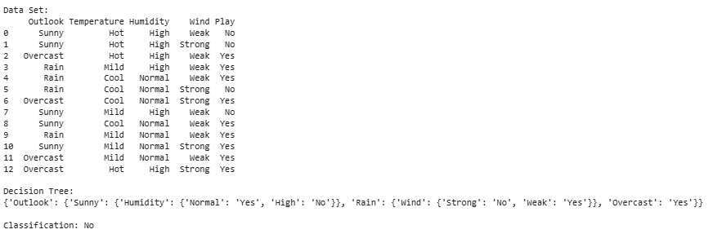

4. Build an Artificial Neural Network by implementing the Backpropagation algorithm and test the same using appropriate data sets.

**Code:**

import numpy as np

from sklearn.model_selection import train_test_split

from sklearn.preprocessing import OneHotEncoder, StandardScaler

from sklearn.datasets import load_iris

def sigmoid(x):

x = np.clip(x, -500, 500)

return 1 / (1 + np.exp(-x))

def sigmoid_derivative(x):

return x * (1 - x)

class NeuralNetwork:

def __init__(self, input_size, hidden_size, output_size, learning_rate=0.01):

self.input_size = input_size

self.hidden_size = hidden_size

self.output_size = output_size

self.learning_rate = learning_rate

np.random.seed(42)

self.W1 = np.random.uniform(-1, 1, (self.input_size, self.hidden_size))

self.b1 = np.zeros((1, self.hidden_size))

self.W2 = np.random.uniform(-1, 1, (self.hidden_size, self.output_size))

self.b2 = np.zeros((1, self.output_size))

def forward(self, X):

self.z1 = np.dot(X, self.W1) + self.b1

self.a1 = sigmoid(self.z1)

self.z2 = np.dot(self.a1, self.W2) + self.b2

self.a2 = sigmoid(self.z2)

return self.a2

def backward(self, X, y, output):

m = X.shape[0]

output_error = y - output

output_delta = output_error * sigmoid_derivative(output)

hidden_error = output_delta.dot(self.W2.T)

hidden_delta = hidden_error * sigmoid_derivative(self.a1)

self.W2 += self.a1.T.dot(output_delta) * self.learning_rate / m

self.b2 += np.sum(output_delta, axis=0, keepdims=True) * self.learning_rate / m

self.W1 += X.T.dot(hidden_delta) * self.learning_rate / m

self.b1 += np.sum(hidden_delta, axis=0, keepdims=True) * self.learning_rate / m

def train(self, X, y, epochs=10000):

for epoch in range(epochs):

output = self.forward(X)

self.backward(X, y, output)

if epoch % 1000 == 0:

loss = np.mean(np.square(y - output))

print(f'Epoch {epoch}, Loss: {loss:.4f}')

def predict(self, X):

output = self.forward(X)

return np.argmax(output, axis=1)

data = load_iris()

X = data.data

y = data.target.reshape(-1, 1)

encoder = OneHotEncoder(sparse_output=False)

y_encoded = encoder.fit_transform(y)

scaler = StandardScaler()

X_scaled = scaler.fit_transform(X)

X_train, X_test, y_train, y_test = train_test_split(X_scaled, y_encoded, test_size=0.2, random_state=42)

nn = NeuralNetwork(input_size=4, hidden_size=5, output_size=3, learning_rate=0.1)

nn.train(X_train, y_train, epochs=10000)

y_pred = nn.predict(X_test)

y_test_labels = np.argmax(y_test, axis=1)

accuracy = np.mean(y_pred == y_test_labels)

print(f'Accuracy: {accuracy * 100:.2f}%')

**Output:**

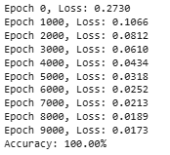

5. Write a program for Implementation of K-Nearest Neighbours (K-NN) in Python

**Code:**

from sklearn.model_selection import train_test_split

from sklearn.preprocessing import StandardScaler

from sklearn.neighbors import KNeighborsClassifier

from sklearn import metrics

import pandas as pd

import numpy as np

url = "https://raw.githubusercontent.com/jbrownlee/Datasets/master/iris.csv"

names = ['sepal-length', 'sepal-width', 'petal-length', 'petal-width', 'class']

dataset = pd.read_csv(url, names=names)

X = dataset[['sepal-length', 'sepal-width', 'petal-length', 'petal-width']]

y = dataset['class']

X_train, X_test, y_train, y_test = train_test_split(X, y, test_size=0.2, random_state=1)

sc = StandardScaler()

X_train = sc.fit_transform(X_train)

X_test = sc.transform(X_test)

knn = KNeighborsClassifier(n_neighbors=5)

knn.fit(X_train, y_train)

y_pred = knn.predict(X_test)

print("Accuracy:", metrics.accuracy_score(y_test, y_pred))

new_sample = [[5.1, 3.5, 1.4, 0.2]]

new_sample = sc.transform(new_sample)

prediction = knn.predict(new_sample)

print("Prediction:", prediction)

**Output:**



6. Write a program to implement Naïve Bayes algorithm in python and to display the results using confusion matrix and accuracy.

**Code:**

from sklearn.model_selection import train_test_split

from sklearn.naive_bayes import GaussianNB

from sklearn import metrics

import pandas as pd

import numpy as np

url = "https://raw.githubusercontent.com/jbrownlee/Datasets/master/iris.csv"

names = ['sepal-length', 'sepal-width', 'petal-length', 'petal-width', 'class']

dataset = pd.read_csv(url, names=names)

dataset['class'] = dataset['class'].map({'Iris-setosa': 0, 'Iris-versicolor': 1, 'Iris-virginica': 2})

X = dataset[['sepal-length', 'sepal-width', 'petal-length', 'petal-width']]

y = dataset['class']

X_train, X_test, y_train, y_test = train_test_split(X, y, test_size=0.2, random_state=1)

gnb = GaussianNB()

gnb.fit(X_train, y_train)

y_pred = gnb.predict(X_test)

print("Accuracy:", metrics.accuracy_score(y_test, y_pred))

print("Confusion Matrix:")

print(metrics.confusion_matrix(y_test, y_pred))

print("Classification Report:")

print(metrics.classification_report(y_test, y_pred))

**Output:**

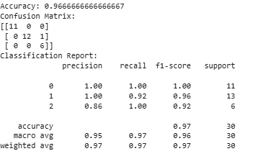

7. Write a program to implement Logistic Regression (LR) algorithm in python

**Code:**

import numpy as np

import pandas as pd

import matplotlib.pyplot as plt

import seaborn as sns

from sklearn.model_selection import train_test_split

from sklearn.preprocessing import StandardScaler

from sklearn.linear_model import LogisticRegression

from sklearn.metrics import accuracy_score, confusion_matrix, classification_report

from sklearn.datasets import load_breast_cancer

data = load_breast_cancer()

X = data.data

y = data.target

X_train, X_test, y_train, y_test = train_test_split(X, y, test_size=0.2, random_state=42)

scaler = StandardScaler()

X_train = scaler.fit_transform(X_train)

X_test = scaler.transform(X_test)

model = LogisticRegression()

model.fit(X_train, y_train)

y_pred = model.predict(X_test)

accuracy = accuracy_score(y_test, y_pred)

conf_matrix = confusion_matrix(y_test, y_pred)

class_report = classification_report(y_test, y_pred)

print(f"Accuracy: {accuracy:.4f}")

print("Confusion Matrix:\n", conf_matrix)

print("Classification Report:\n", class_report)

plt.figure(figsize=(5,4))

sns.heatmap(conf_matrix, annot=True, fmt='d', cmap='Blues', xticklabels=data.target_names, yticklabels=data.target_names)

plt.xlabel('Predicted')

plt.ylabel('Actual')

plt.title('Confusion Matrix')

plt.show()

**Output:**

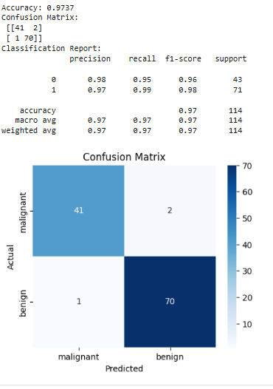

8. Write a program to implement Linear Regression (LR) algorithm in python

**Code:**

import numpy as np

import pandas as pd

import matplotlib.pyplot as plt

from sklearn.model_selection import train_test_split

from sklearn.linear_model import LinearRegression

from sklearn.metrics import mean_squared_error, r2_score

np.random.seed(42)

X = 2 * np.random.rand(100, 1)

y = 4 + 3 * X + np.random.randn(100, 1)

X_train, X_test, y_train, y_test = train_test_split(X, y, test_size=0.2, random_state=42)

model = LinearRegression()

model.fit(X_train, y_train)

y_pred = model.predict(X_test)

mse = mean_squared_error(y_test, y_pred)

r2 = r2_score(y_test, y_pred)

print(f"Mean Squared Error: {mse:.4f}")

print(f"R² Score: {r2:.4f}")

print(f"Intercept: {model.intercept_[0]:.4f}")

print(f"Coefficient: {model.coef_[0][0]:.4f}")

plt.scatter(X_test, y_test, color="blue", label="Actual Data")

plt.plot(X_test, y_pred, color="red", linewidth=2, label="Regression Line")

plt.xlabel("Independent Variable (X)")

plt.ylabel("Dependent Variable (y)")

plt.title("Linear Regression Model")

plt.legend()

plt.show()

**Output:**

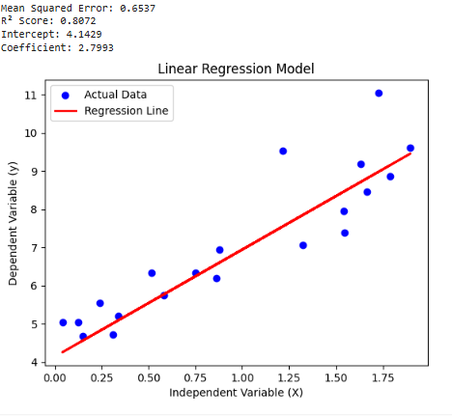

9. Compare Linear and Polynomial Regression using Python

**Code:**

import numpy as np

import matplotlib.pyplot as plt

from sklearn.model_selection import train_test_split

from sklearn.preprocessing import PolynomialFeatures

from sklearn.linear_model import LinearRegression

from sklearn.metrics import mean_squared_error, r2_score

np.random.seed(42)

X = 6 * np.random.rand(100, 1) - 3

y = 0.5 * X**2 + X + 2 + np.random.randn(100, 1)

X_train, X_test, y_train, y_test = train_test_split(X, y, test_size=0.2, random_state=42)

lin_reg = LinearRegression()

lin_reg.fit(X_train, y_train)

y_pred_linear = lin_reg.predict(X_test)

poly_features = PolynomialFeatures(degree=2)

X_train_poly = poly_features.fit_transform(X_train)

X_test_poly = poly_features.transform(X_test)

poly_reg = LinearRegression()

poly_reg.fit(X_train_poly, y_train)

y_pred_poly = poly_reg.predict(X_test_poly)

mse_linear = mean_squared_error(y_test, y_pred_linear)

r2_linear = r2_score(y_test, y_pred_linear)

mse_poly = mean_squared_error(y_test, y_pred_poly)

r2_poly = r2_score(y_test, y_pred_poly)

print(f"Linear Regression MSE: {mse_linear:.4f}, R² Score: {r2_linear:.4f}")

print(f"Polynomial Regression MSE: {mse_poly:.4f}, R² Score: {r2_poly:.4f}")

X_range = np.linspace(-3, 3, 100).reshape(-1, 1)

y_linear_pred = lin_reg.predict(X_range)

y_poly_pred = poly_reg.predict(poly_features.transform(X_range))

plt.scatter(X, y, color="blue", label="Actual Data", alpha=0.6)

plt.plot(X_range, y_linear_pred, color="red", label="Linear Regression", linewidth=2)

plt.plot(X_range, y_poly_pred, color="green", label="Polynomial Regression", linewidth=2)

plt.xlabel("Feature X")

plt.ylabel("Target y")

plt.title("Linear vs Polynomial Regression")

plt.legend()

plt.show()

**Output:**

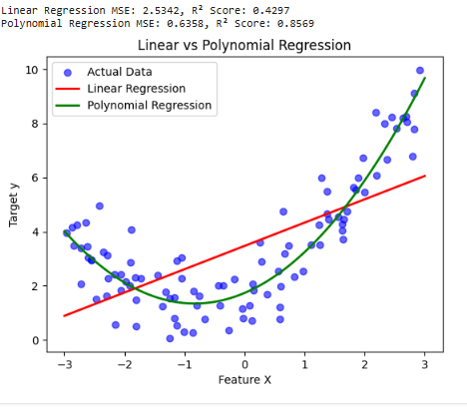

10. Write a Python Program to Implement Expectation & Maximization Algorithm

**Code:**

import numpy as np

import matplotlib.pyplot as plt

from scipy.stats import multivariate_normal

from sklearn.mixture import GaussianMixture

np.random.seed(42)

X1 = np.random.normal(2, 1, (150, 1))

X2 = np.random.normal(-2, 1, (150, 1))

X = np.vstack((X1, X2))

k = 2

means = np.random.choice(X.flatten(), k).reshape(k, 1)

covariances = [np.array([[np.var(X)]]) + 1e-6 for _ in range(k)]

weights = np.full(k, 1/k)

responsibilities = np.zeros((X.shape[0], k))

for _ in range(100):

    responsibilities.fill(0)

    for i in range(k):

        responsibilities[:, i] = weights[i] * multivariate_normal.pdf(X[:,0], mean=means[i][0], cov=covariances[i])

    responsibilities /= np.clip(responsibilities.sum(axis=1)[:, None], a_min=1e-10, a_max=None)

    Nk = responsibilities.sum(axis=0)

    weights[:] = Nk / X.shape[0]

    means[:] = (responsibilities.T @ X) / Nk[:, None]

    for i in range(k):

        centered_X_i_mean_diffs_squared_summed_over_Ni_divided_by_Ni_plus_epsilon \

            =(responsibilities[:, i][: ,None]*(X - means[i])**2).sum(axis=0)/Nk[i]+ 5e-7

        covariances[i][:,:] += centered_X_i_mean_diffs_squared_summed_over_Ni_divided_by_Ni_plus_epsilon

gmm_model=GaussianMixture(n_components=k,covariance_type='full',random_state=np.random.randint(low=42))

gmm_model.fit(X)

gmm_preds=gmm_model.predict(X)

plt.scatter(X,gmm_preds,cmap='coolwarm',c=gmm_preds,label="Clusters")

plt.scatter(means,np.zeros_like(means),marker='x',color='black',s=100,label="Final Means")

plt.title("Expectation-Maximization(GMM)")

plt.legend()

plt.show()

print("Final Means:", means.flatten())

print("Final Weights:", weights)

**Output:**

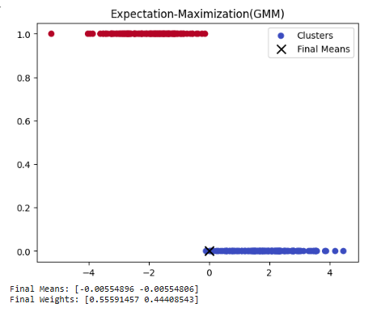

11 Write a program for the task of Credit Score Classification

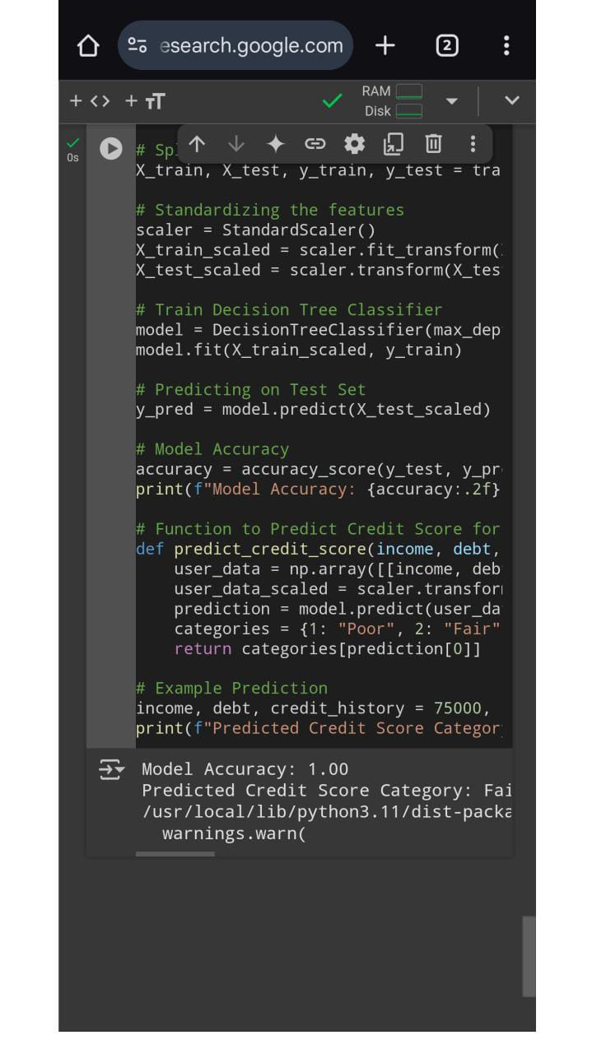

12 Implement Iris Flower Classification using KNN

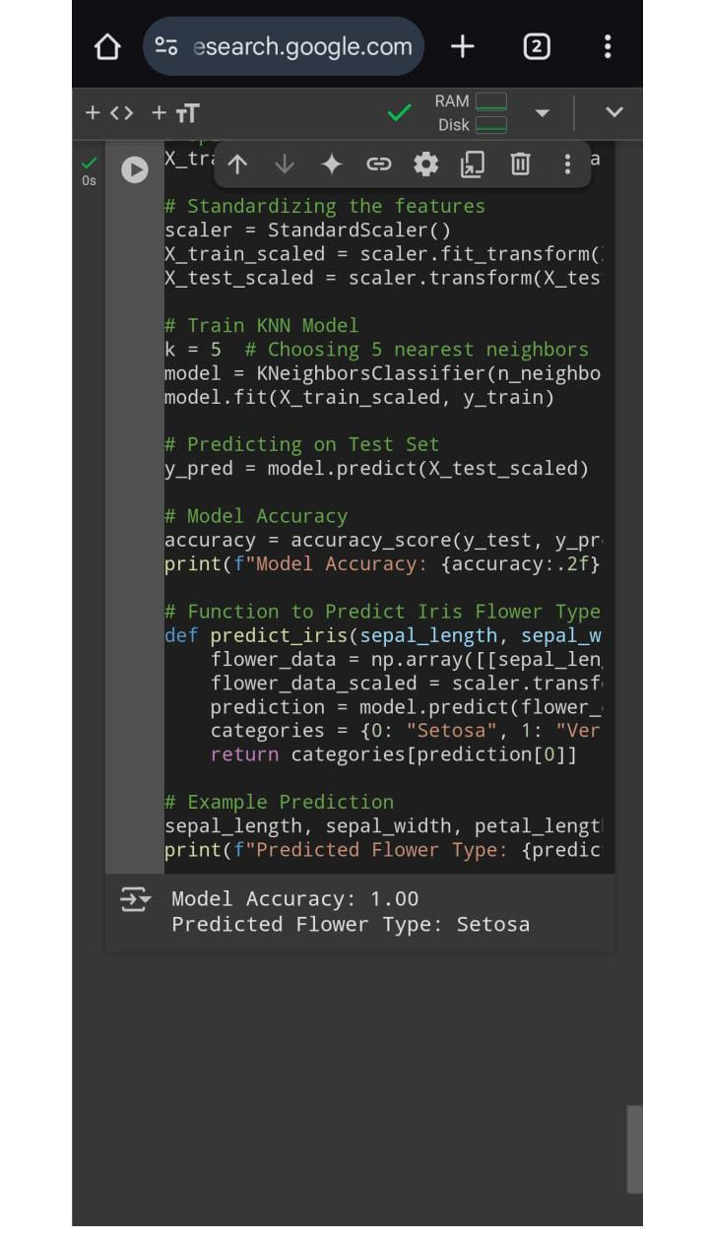

13 Implement the Car Price Prediction Model using Python

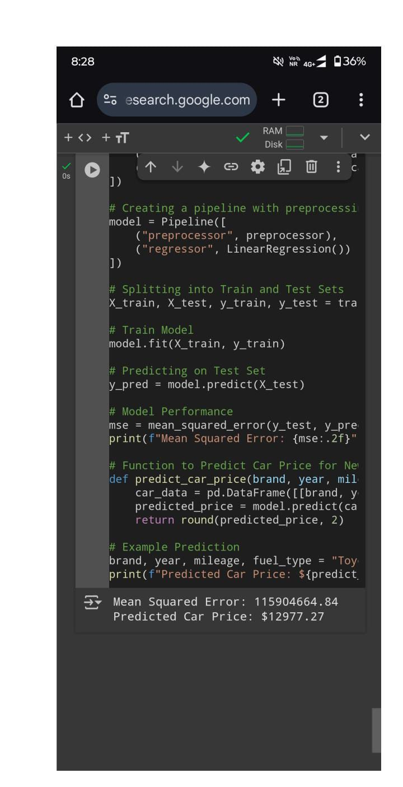

14 Implement House price Prediction using appropriate machine learning algorithm

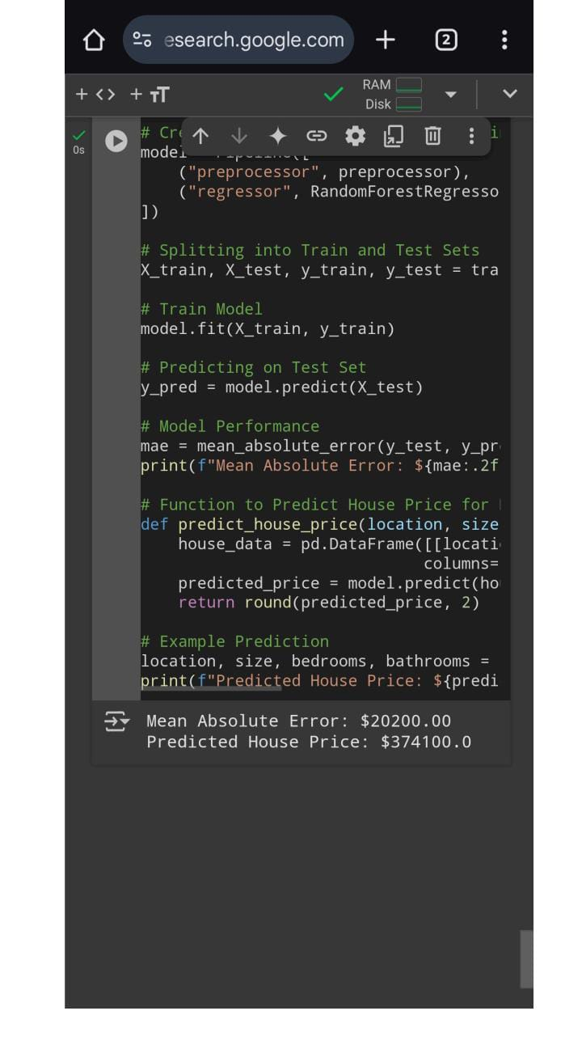

15 Implement Iris Flower Classification using Naive Bayes classifier

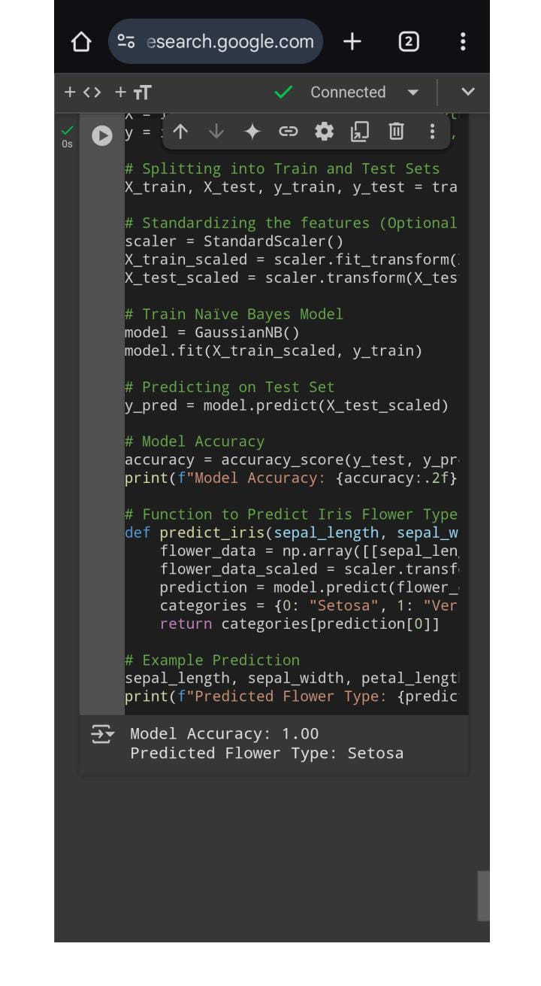

16 Compare different types Classification Algorithms and evaluate their performance.

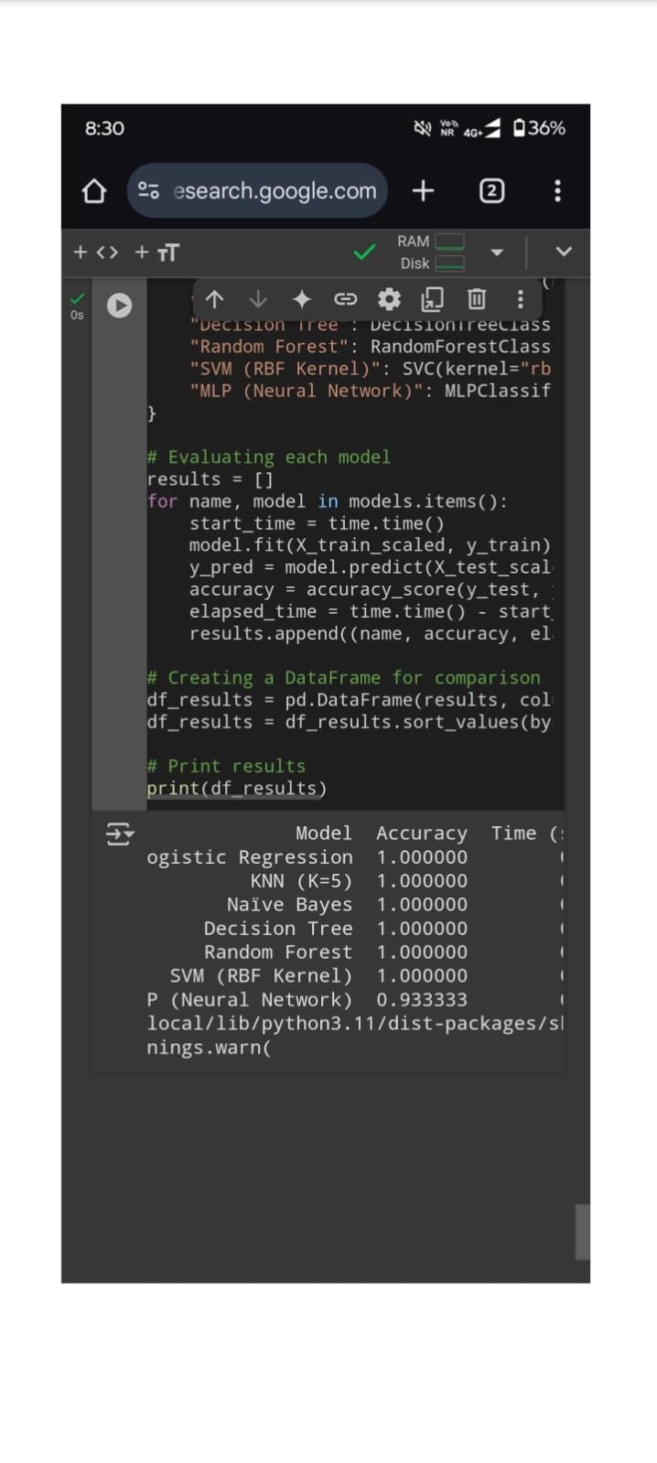

17 Implement Mobile Price Prediction using appropriate machine learning algorithm

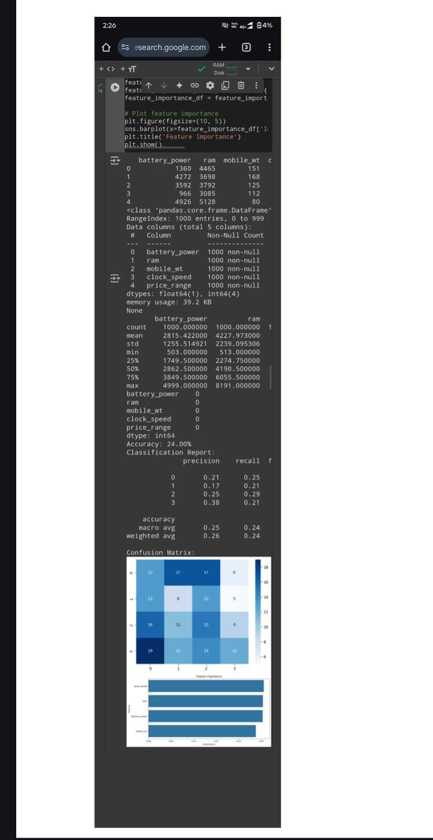

18 Implement Perceptron based IRIS classification

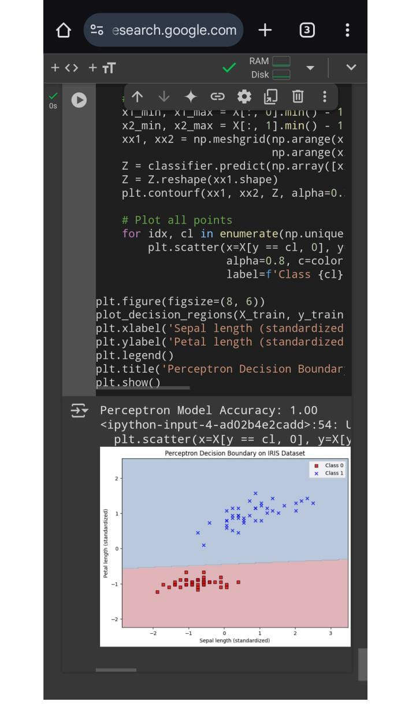

19 Implementation of Naive Bayes classification for Bank Loan prediction

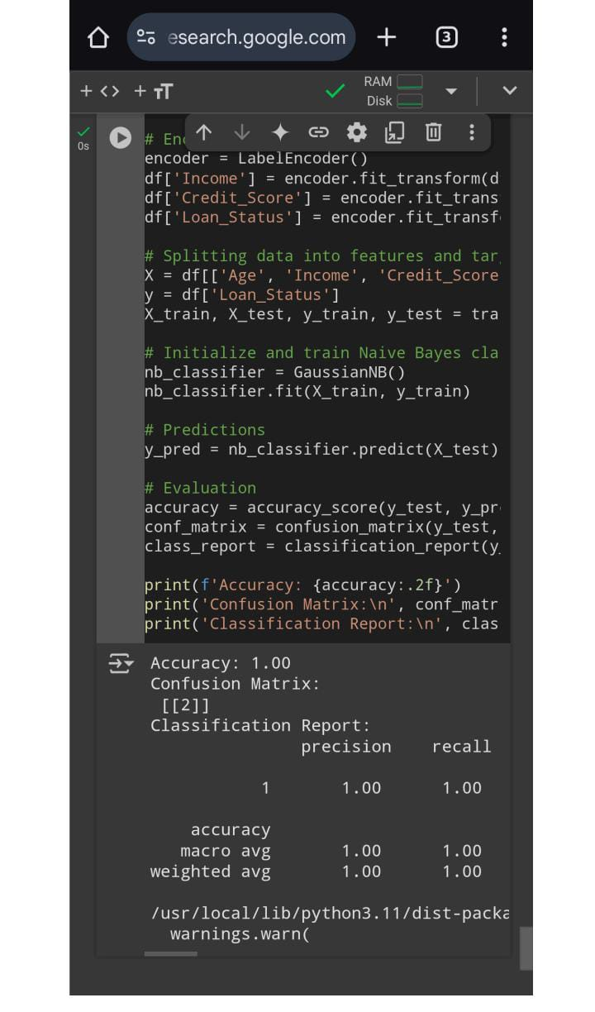

20 Implement Future Sales Prediction using a suitable machine learning algorithm

